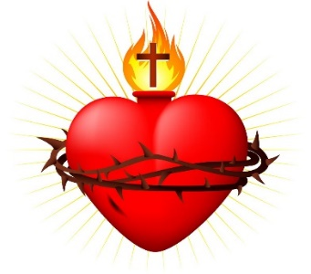
Sacred heart cathedral
406 Steele Street, Whitehorse (YT), Y1A 2C8
Phone: (867) 667-2437
Email: office@sacredheartcathedral.ca or office@sacredheartcathedral.ca
Web: www.sacredheartcathedral.ca

BAPTISMAL FORM
Please fill out this form and bring with you to the Baptism Classes which are on the the first and second Friday of each month. You must also set up an appointment with the Priest doing the Baptism.
Part 1. Child’s Information
Full name:
Date of birth: |  | Place of birth:
Part 2. Parents’ Information (AT LEAST ONE OF THE PARENTS MUST GIVE CONSENT. THERE MUST BE SOME ASSURANCE THAT THE CHILD WILL BE BROUGHT UP IN THE CATHOLIC FAITH.)
Mother’s first and maiden name:
Mother’s religion:
Father’s full name:
Father’s religion:
Parents’ Address:
Phone number(s): |  | Email:
How long have you been attending mass at this church?
Have you had other children baptized at this church?
□ Sacramental Marriage or □ Civil Marriage
Date of marriage: | Place of marriage:
Part 3: Godparents’ Information (MUST BE AT LEAST 16 YEARS OF AGE. ONE MUST BE FEMALE AND ONE MALE. AT LEAST ONE OF THE GODPARENTS MUST BE A PRACTICING CATHOLIC WHO HAS BEEN CONFIRMED AND HAS RECEIVED THE EUCHARIST. A BAPTIZED NON-CATHOLIC MAY BE A WITNESS ALONG WITH A CATHOLIC GODPARENT.)
Full name:
Full name:
If Godparents are not present at the Baptism, Full name(s) of proxy:
Part 4. Sacramental Information
Place of baptism (Parish/Mission, City/Town and Territory/Province):
Proposed date(s) for the baptism:
Baptismal preparation dates (Min. two meetings with a priest/catechist):
For office use only:
Baptismal prep completed by (Priest/Catechist): ____________________________________ Date: __________________
Date and time of Baptism: __________________________________ Celebrant: _______________________________
□ Certificate issued / □ Recorded in parish register AND □ Sent to Chancery / OR □ Sent to parish of baptism

