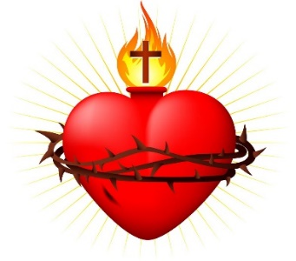
Sacred heart cathedral
406 Steele Street, Whitehorse (YT), Y1A 2C8
Phone: (867) 667-2437
Email: office@sacredheartcathedral.ca or office@sacredheartcathedral.ca
Web: www.sacredheartcathedral.ca

FIRST RECONCILIATION & FIRST COMMUNION
REGISTRATION FORM

PLEASE PRINT WHEN FILLING OUT THIS FORM

PLEASE NOTE: This registration can be only accepted and processed only if accompanied by a photocopy of your child’s BAPTISMAL CERTIFICATE.
The children cannot prepare for the Fist Holy Communion if they did not first prepare for and celebrate their first Reconciliation. The two sacraments go together.
Part 1. Child’s Information
Full name:
Date of birth: | Place of birth:
Child’s School:
Mother’s first and maiden name:
Mother’s religion:
Father’s full name:
Father’s religion:
Parents’ Address:
Phone number(s): | Email:
How long have you been attending mass at this church?
Have you had other children baptized at this church?
□ Sacramental Marriage or □ Civil Marriage
Date of marriage: | Place of marriage:
NAME AND ADDRESS OF CHURCH WHERE YOUR CHILD WAS BAPTIZED
PLACE OF BAPTISM: (Parish/Mission, City/Town and Territory/Province, Country):
PARISH OFFICE NOTES:

