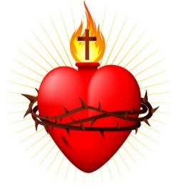
Sacred Heart Cathedral
406 Steele street, Whitehorse, Yukon, Y1A 2C8
Phone: (867) 667-2437 Email: office@sacredheartcathedral.ca www.sacredheartcathedral.ca

Marriage Preparation Registration

Name: ________________________________________
Date of Birth : _____________________

Mailing address: ____________________________________________________

__________________________________________________________________
Phone number: ______________________ Cell: ______________________
Email address: ______________________________

Future Spouse: ________________________________________
Date of Birth: ______________________
Mailing address: ____________________________________________________

__________________________________________________________________
Phone number: ______________________ Cell: ______________________
Email address: ______________________________

Canadian citizen yes or no (please circle one)
Date of Wedding: _____________________________________________
Location of Wedding: _____________________________________________

Please note that at the first interview with the priest please have a valid Baptism Certificate that can only be 6 months old.
Please see our website for for information and policies reguarding weddings or marriage preparation on our website sacredheartcathedral.ca.

