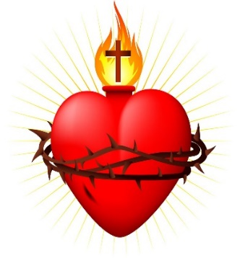
SACRED HEART CATHEDRAL
406 Steele Street, Whitehorse (YT), Y1A 2C8
Phone: (867) 667-2437 Fax: (867)667-7529
Email: office@sacredheartcathedral.ca Web: www.sacredheartcathedral.ca

Parish Registration

Name: ___________________________________________________________

Spouse: ___________________________________________________________

Mailing Address: ________________________________________________________

_______________________________________________________________________

Phone number: ______________________ Cell: ________________________

Email Address: __________________________________________________________

Canadian Citizen Yes or No (please circle one)

Sacraments Needed

Children Birthdate Baptism First Communion Confirmation

________________________________________________________________________

________________________________________________________________________

________________________________________________________________________
________________________________________________________________________

If you have adult children (over the age of 18) living at home, they should register
Separately. This can be done on the reverse side of this form.

If you are not currently using Sunday Collection envelopes and would like a box you
can pick up at front of the church, please indicate below.
(Using envelopes ensures that you receive tax receipt at the end of the year.)

Sunday collection envelopes or Direct Deposit (please circle one)

Please return this form to the parish office at 406 Steele Street or drop it in Sunday collection basket.

